ЕГЕМБЕРДИЕВА Айнур Килишбеккызы,
Зоя Космодемьянская атындағы №23 мектеп-лицейінің ағылшын тілі пәні мұғалімі.
Шымкент қаласы

UNIT REVIEW 6 (PASSIVE VOICE)

Learning objectives | 8.1.6.1organise and present information clearly to others  8.3.7.1 use appropriate subject-specific vocabulary and syntax to talk about a range of general topics, and some curricular topics  8.4.1.1 understand the main points in texts on a growing range of unfamiliar general and curricular topics, including some extended texts
Lesson objectives | Learners will be able to:  - Use nouns related to art  - Use adjectives for describing art.  - review how to use Present and passive form  - Write the form of present and past passive form
Plan

Stages/Time | Teachers’ actions | Students’ actions | Assessment criteria | Resources
Beginning of the lesson  5 min | Organization moment  1.Greeting.  Ask about the weather.  The teacher sets the lesson objectives, letting students know what to anticipate from the lesson.  Warm-up  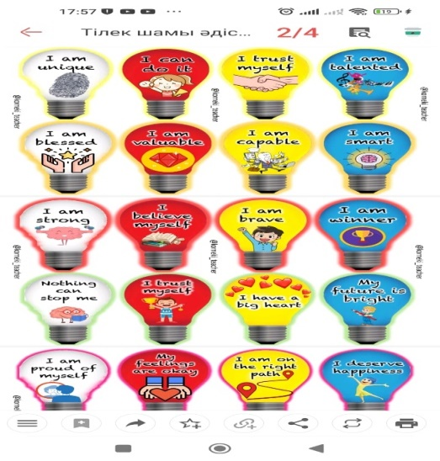  students wish each other by holding a wishes lamp  Lead – In  • Listen to the song and guess | The aim: To develop pupils speaking skills and create friendly atmosphere  Efficiency: By telling the wishes they show their appreciations .  Students of the class are listed.  Students listen to the song.  Determine the topic and purpose of the lesson | At the organization moment teacher tries to award active pupils. «The praise» method is used to evaluate pupils with phrases like:  “Good job!  Well done!”  Formative Assessment  Good job! | Pictures  Light bulbs  Student’s book
Middle of the lesson  Presentation part  35 min | Presentation(Passive voice)  Teacher gives information about Present simple passive and past simple passive.(review)  Task 1  Ex: 1 P: 77  Match the words  Teacher gives cards with the words .  Differentiation:  Weak Ss will be given the translation of the words  Task 2  Wordwall  Complete the sentences. Use the present simple form of the Passive .  1 Coffee …isn’t grown… (grow) in Iceland.  2 The Olympic Games …………………. (hold) every year.  3 Spanish …………………. (speak) in Argentina.  4 English …………………. (teach) in Polish schools.  5 Tricks …………………. (play) on April Fool’s Day.  6 Uniforms …………………. (wear) by most police officers.  7 Meat …………………. (sell) in a greengrocer’s.  8 Easter …………………. (celebrate) in every country of the world.  Differentiation:  Weak Ss will be supported by strong Ss  Task 3  Complete the sentences with the words given below.  Use the past simple form of the Passive .  bring build drop kill paint write  1 The Hobbit …was written…… by J.R.R Tolkien.  2 The Empire State Building ………………… in 1931.  3 Potatoes ………………… to Europe from America.  4 More than 1,500 people ………………… when the Titanic sank.  5 In 1985, a bottle of wine worth $250,000 ………………… by a waiter.  6 The Mona Lisa ………………… by Leonardo da Vinci.  Differentiation:  Weak Ss will be given the translation of the words  Task 4  Pre-reading task  1.Video  Questions(Wh questions)  1.Why is the Rosetta Stone so important?  2.What does the Rosetta stone tell us?  3.Why is the stone known as the “Rosetta sone”?  4.Who deciphered (расшифровать) what was written on the Rosetta stone?  Teacher gives unknown words from the text  Egyptian stone-Египеттік тас  Tablet-тақта, блокнот, табличка  picture-writing-пиктографиялық хат, суретті хат  soldiers-солдат  mystery-құпия  Champollion-Жан Франсуа Шампальон египтологияның негізін салушы  Ancient-көне  Treasures-қымбат дүние, сокровище  Work with the text  Ss read the text  Complete the text with the given words in the brackets  (in the correct form)  The Rosetta Stone is an ancient Egyptian stone tablet with words on it from 196 BC. The words 1…are written…… (write) in three different languages, including Egyptian picture-writing. The stone 2…………………. (find) in 1799 by French soldiers who were fighting in Egypt. After the war, it 3…………………. (take) to England. Over the next few years, most of the words on the stone 4…………………. (translate), but nobody could understand the picture-writing. That mystery 5…………………. (not solve) until 1822, when a French academic called Champollion translated them. The fact that ancient Egyptian picture-writing 6…………………. (understand) today is mostly thanks to Champollion’s work. Today, the Rosetta Stone 7…………………. (keep) in the British Museum, where many ancient Egyptian treasures 8…………………. (see) by millions of visitors each year.  Post- reading task  Ss will speak about Rosetta Stone  Task 5  Rewrite the sentences from active voice into passive voice  1 They don’t make cars in Wales.  2 They wear uniforms at most British schools.  3 John Pemberton invented Coca-Cola.  4 They do a lot of shopping online.  5 British people send 2 billion text messages a week.  6 They produced wine in France in Roman times. | -Students revise grammar rules  -Give examples  Ss match the verbs with correct forms(Past participle forms)  Ss complete the sentences  Ss complete the sentences using the words in the correct form  -Ss watch the video  -Answer the questions  -Read the text  -Complete the text  Ss speak about Rosetta sone  Ss Rewrite the sentences from active voice into passive voice | Good job!  Assessment criteria  - Match the words correctly  Descriptor:  - choose the correct words  Assessment criteria:  -Use present simple passive .  Descriptor:  - Complete the sentences in the present simple passive  Assessment criteria:  -choose the words correctly  -Use past simple passive .  Descriptor:  - Complete the sentences in the past simple passive  Assessment criteria:  -Watch the video  -Ss answer the questions.  Descriptor:  Ss give full answer.  Assessment criteria:  -Read the text  -Complete the text  Descriptor:  Ss complete the text with the given words in the correct form.  Assessment criteria:  -Use passive voice  Descriptor:  Ss rewrite the sentences using Passive voice |   Cards  Activeboard  https://wordwall.net/resource/68668587  Worksheets  Activeboard  Worksheets  Activeboard  Activeboard  Video  https://youtu.be/CA3DU6gaa74?si=BuF8sSPQzXgfavsz  Cards  Cards  Cards
End of the lesson  5 min | FEEDBACK  Learners provide feedback on what they have learned at the lesson.  This is a way for students to self-reflect on their progress in the lesson.  Home task:  Ex: 7,8 P: 55 WB |  | Students use their stickers to show their knowledge according to the lesson. | Poster  Activeboard  Stickers

